Ezekiel Yu

**JS Project: Speed**

Background:  
Speed is a simple but adrenaline-packed card game for two players (1 human, 1 AI). Before the game starts, each player has 5 cards in their hand and a 15-card pile to draw from. There are 2 empty stacks in the middle and a reserve of 6 cards each on either side. When the game starts, the top card of each reserve is flipped onto its respective stack, and players can begin playing cards that are numerically consecutive to the top card of either stack, replenishing their hand up to a maximum of 5 cards. Reserve cards can be flipped when neither player can play a card; if a reserve runs out, its corresponding stack is flipped over to become the new reserve. When a player has no cards left in their hand or pile, they win!

Functionality and MVPs:  
In Speed, users will be able to:  
1) View instructions and set AI difficulty  
2) Use their keyboard to select cards from their hand (QWERT) or draw cards from their pile (spacebar)  
3) Use their mouse to choose a stack on which to play their selected card  
4) Select a background theme or music (optional, may not get to this)  
  
Wireframe:  
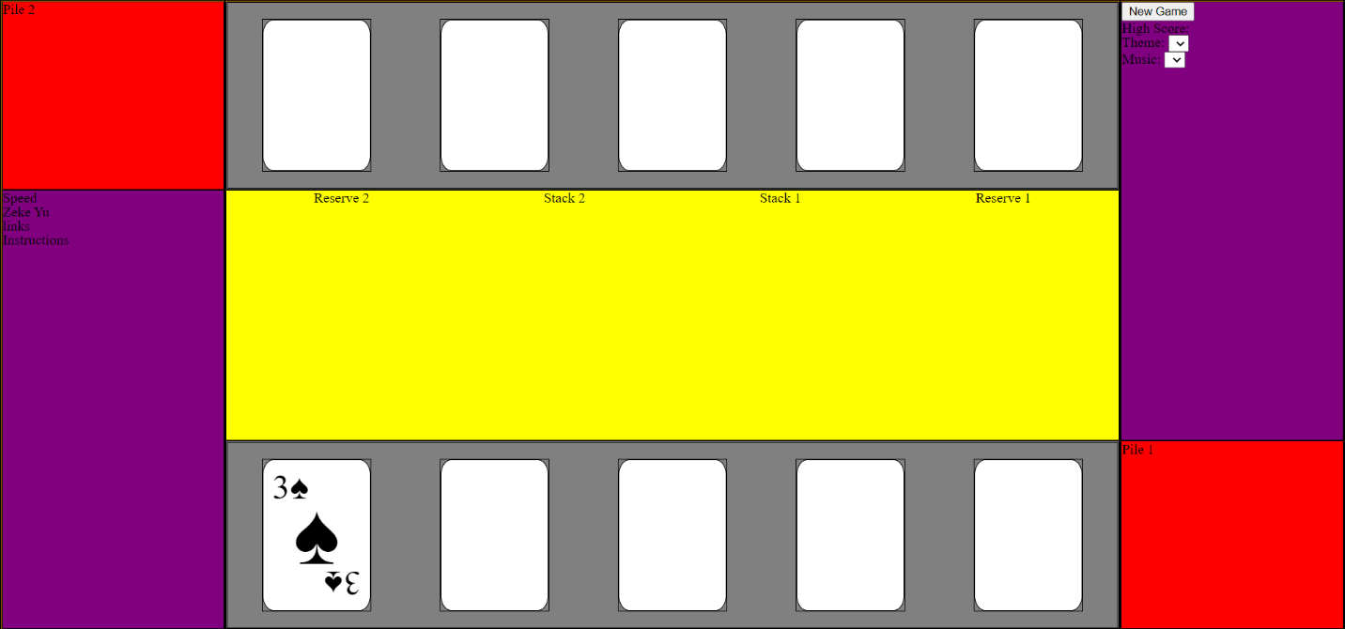  
Rough CSS outline, not set in stone yet. Instructions will probably show a popup on hover. May add radio buttons below new game for AI difficulty. Theme and music will be drop-down menus. Selected card in hand will have a glow effect. May add animations for drawing from pile, etc.

Technologies:  
-Webpack and Babel to bundle and transpile the source JavaScript code  
-npm to manage project dependencies  
-May explore additional technologies like three.js to improve visuals later on

Implementation Timeline:  
Monday: Focus on getting game playable (game logic, event listeners/handlers, AI)  
Tuesday: Finish making game playable if not already. Work on CSS styling and general layout  
Wednesday: Experiment with animating cards and other visual effects. Add background and music choices if there is time  
Thursday: Last-minute touch-ups. Deploy project